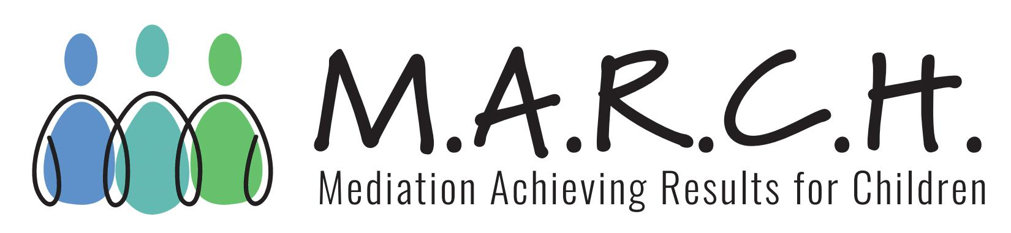
M.A.R.C.H. Inc. 2 S. Water St., Liberty, MO 64068
Phone: 1-800-595-9750 Fax: 816-708-2715 Email: dkuhlman@marchmediation.org

Contract for Supervised Visitation Services (FSD IV-D cases)

M.A.R.C.H. Incorporated has received Federal and State funding to operate the M.A.R.C.H. program. Beginning October 1, 2022, M.A.R.C.H. will refer eligible parties for supervised visitation with M.A.R.C.H. approved contract providers. Parties who are actively receiving IV-D services from the Department of Social Service, Family Support Division are eligible for these services at no cost.

______________________________________________________meets the qualifications listed below, and wishes to provide supervised visitation services on referral for the M.A.R.C.H. Supervised Visitation program. Supervised Visitation as defined in RSMo §§452.400 is visitation which takes place in the presence of a responsible adult appointed by the court for the protection of the child. Supervised visitation services will also be provided for eligible parties upon a voluntary service request.

A supervised visitation is defined as face-to-face, monitored telephone calls, or monitored virtual visits. Supervised visitations should not last longer than two (2) hours per session. The visit supervisor must receive written notification and approval from M.A.R.C.H. Inc before a supervised visitation is conducted for M.A.R.C.H. cases.
The visit supervisor must upload the following information to MyCase for our records:
- Completed W-9
- Proof of age - 21 years of age minimum
  - Copy or picture of valid driver’s license
- Signed Supervised Visitation contract for IV-D cases
- Proof of registration on the Family Care Safety Registry (FCSR)
  - Screenshot or letter from FCSR verifying registration
Visit Supervisor will be compensated at the following rates:
- Standard Supervised Visit Invoice Rate - $50 per visit - up to 2 hours
- Federal Holiday Supervised Visit Invoice Rate - $100 per visit - up to 2 hours
  - Federal Approved Holidays
- Less than 24 hour Cancellation/No Show Supervised Visit Invoice Rate - $25 flat fee
The visit supervisor shall not invoice if the supervised visitation was cancelled 24-hours or more in advance. Invoice for services must be uploaded to MyCase within thirty (30) days of completing services. M.A.R.C.H. Inc must submit State of MO invoices and reports by the 10th of each month; therefore, visit Supervisors will be paid after the 10th of the following month after invoice submission. The M.A.R.C.H. fiscal year is Oct 1 - Sep 30; therefore, no service invoice will be paid when submitted after September 30 in any year when the service occurred in the prior 12 months. No amounts will be withheld from the visit supervisor’s compensation for taxes.

It is agreed that the visit supervisor shall perform the duties under this agreement as an independent contractor to M.A.R.C.H. Inc. The visit supervisor is not to be deemed as an employee of M.A.R.C.H. Inc. and shall not have or claim any right arising from employee status. The visit supervisor has the sole discretion to determine the manner in which supervised visitation services are to be scheduled and conducted in conformity with M.A.R.C.H. Inc. program policy and guidelines. M.A.R.C.H. Inc. specifically reserves the right to terminate this agreement if the visit supervisor fails to comply with program guidelines.

Please provide the following Visit Supervisor Contact Information:

Office address (if applicable):____________________________________________________________
Home address: ________________________________________________________________________ Phone:_______________________________________________________________________________
Fax:_________________________________________________________________________________
e-mail address: ________________________________________________________________________

Visit Supervisor shall conduct services from a location which is accessible to persons with a disability or has access to facilities which comply with current Americans with Disabilities Act Standards.

Please list the Missouri Circuits/Counties in which the Visit Supervisor can provide services. These will be listed and shared on our website with a provided professional picture, biography and/or description of services.
_____________________________________________________________________________________
_____________________________________________________________________________________

Visit Supervisor will perform the following services in connection with cases referred for supervised visitation services.

1. It is recommended that the visit supervisor maintain a policy of professional liability insurance covering supervised visitation services. If secured, Visit Supervisor will provide M.A.R.C.H. Inc. with a copy of the declaration page from said policy or other proof of professional liability insurance. The undersigned visit supervisor consents to the release of information from the professional liability insurance carrier for the purpose of determination of compliance with the above insurance requirements. Visit Supervisor will perform work at own risk, and indemnifies M.A.R.C.H. Inc against all loss, damages, expense, and liability resulting from injury to person or property.

2. Visit Supervisor agrees to comply with the M.A.R.C.H. policy manual in the delivery of supervised visitation services.

3. It is the goal of the M.A.R.C.H. program to complete supervised visitation services within sixty (60) days from the date of request or court order for services. Visit Supervisor will schedule supervised visits with the parties in a timely manner, and at the convenience of the parties when possible. Unless directly indicated by the Court, the location(s) of the supervised visit(s) will be determined by the visit supervisor.

4. Visit Supervisor agrees to ensure that participants are notified of the time, date, method (e.g. face-to-face, phone, or virtual), and location scheduled for the session(s) by phone or in writing (e.g., mail, email, text) in advance.

5. When the visit supervisor is unable to make contact with participants within ten (10) days of receiving a referral, the visit supervisor will immediately notify M.A.R.C.H. via MyCase messaging.

6. The visit supervisor agrees to notify M.A.R.C.H. via MyCase messaging of the date, time, method (e.g., face-to-face, phone, or virtual) and place of the supervised visitation session(s) as soon as it is scheduled.

7. Visit supervisor agrees to advise participants of individual program policies and will ensure that the parties acknowledge receipt of said rules. Visit Supervisor may use the M.A.R.C.H. form agreement or may incorporate those terms in a form designed by the visit supervisor. The visit supervisor shall maintain a signed copy of said guidelines on file.

8. For the purposes of the M.A.R.C.H. Program, visit supervisor is considered a mandated reporter of child abuse and as such must report any suspected abuse to the proper authorities in accordance with RSMo §§210.110 et seq.

9. Visit Supervisor shall be present to supervise the visit only. Parties are responsible for ensuring that the child(ren)’s behavior is appropriate and for taking the initiative to correct it, if necessary. If the parties cannot control the child(ren)’s behavior, the supervised visitation session must be terminated.

Signed this ____________day of ______________________, 20______.

____________________________________________________________________________________
Visit Supervisor

____________________________________________________________________________________
Dawn E. Kuhlman, MA, Executive Director Date

